Civil society - academic partnerships for transformed & transformative ocean governance

TRANSFORMED & TRANSFORMATIVE OCEAN GOVERNANCE CONFERENCE

NELSON MANDELA UNIVERSITY

(Thursday 23 January, 16.30 - 17.20)

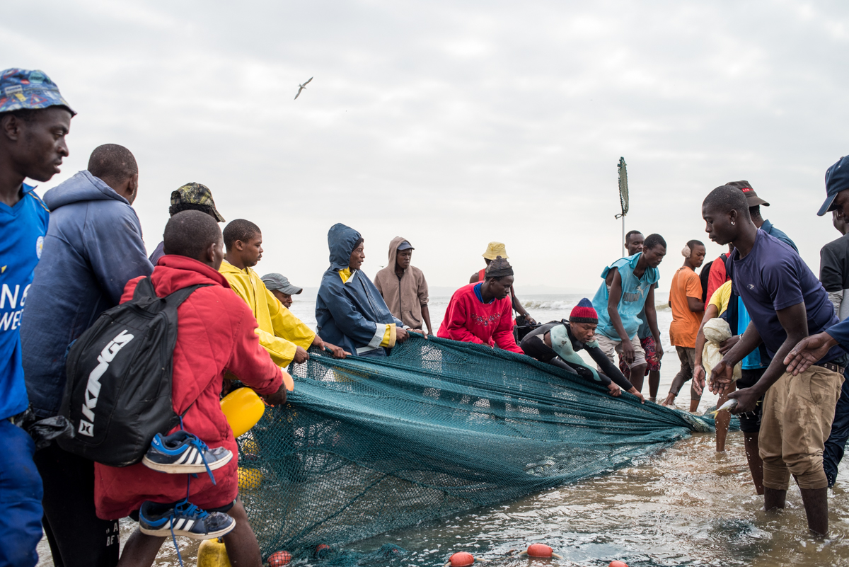

Panellists 10 minute presentations: What are the key concerns of your constituents with regards to the Blue Economy / Operation Phakisa; and what are your current strategies for responding to these concerns?

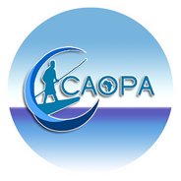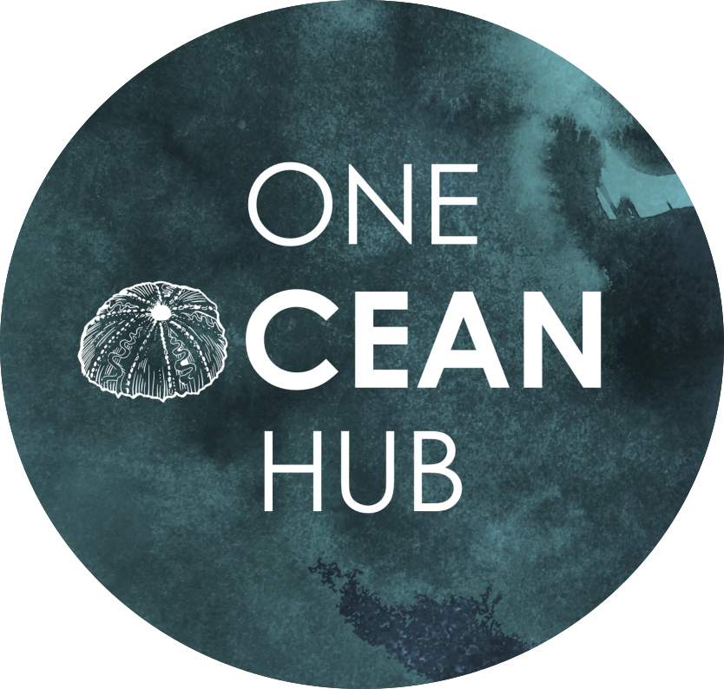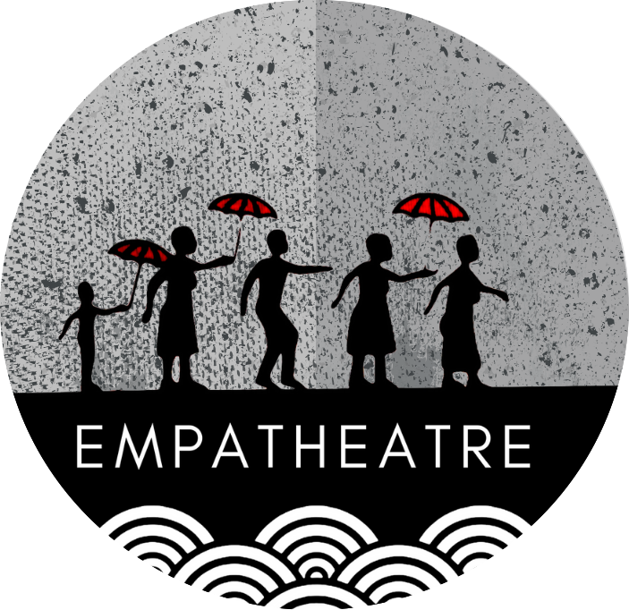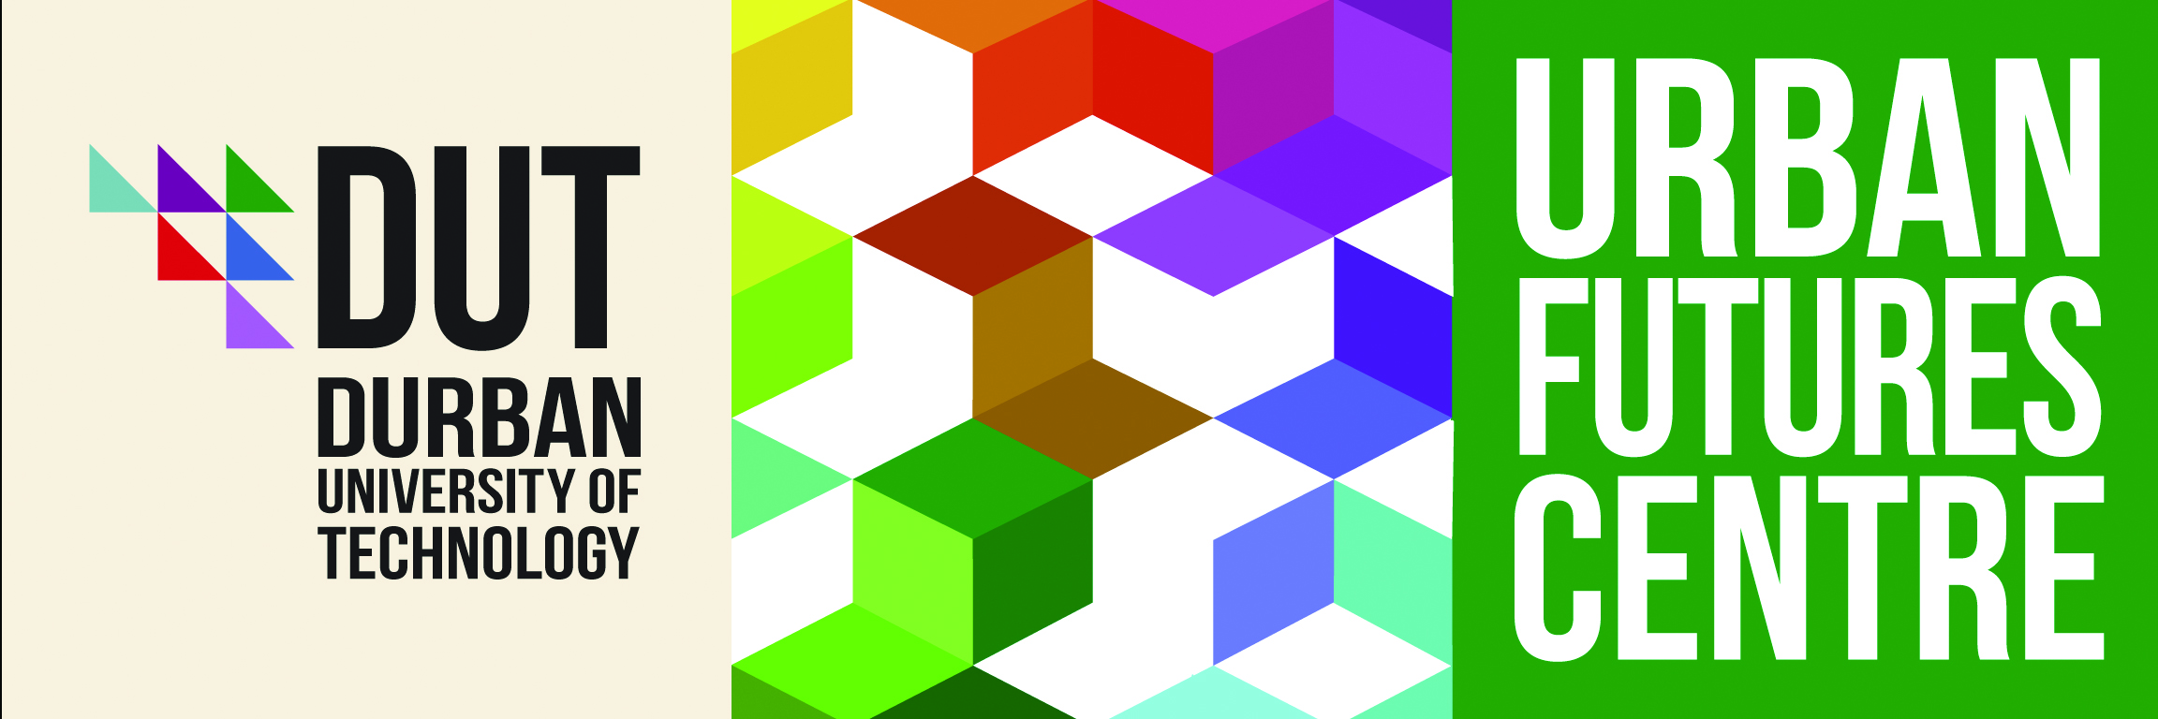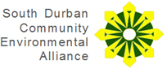

2 Questions for panellists:

- What opportunities and /or risks do you see for working in partnership with academic researchers to respond to the concerns of your organisation / constituents?
- What advice do you have for academic researchers wishing to work in ethical, meaningful partnership with civil society organisations?

Chair: Dylan McGarry is a Senior Research at the Environmental Learning Research Centre (ELRC) – Rhodes University, Co-Director for two research programs for the One Ocean Hub, Co-Founder and Director of Empatheatre, legislative theatre company.

Rapporteur: Kira Erwin: is a sociologist, and Senior Researcher, at the Urban Futures Centre at the Durban University of Technology in Durban, South Africa. Her research and publications focus largely on race, racialization, racism and anti-racism work within the urban context. She is also a co-investigator in the One Ocean hub, and researcher in the Empatheatre collective.

Co-Chair & Respondent: Taryn Pereira: Environmental Learning Research Centre (ELRC) – Rhodes University, One Ocean Hub, a co-investigator in the Empatheatre collective (Taryn has also worked as an activist at the Environmental Monitoring Group (EMG) for the past decade)

https://www.ru.ac.za/elrc/
https://oneoceanhub.org/
https://www.emg.org.za/

Panelist 1: Sherelee Odayer is the project officer responding to Oil, Gas and Energy and the unjust developments associated with SA’s Blue Economy at the South Durban Community Environment Alliance(SDCEA) (also representing Groundwork)
http://sdcea.co.za/
https://www.groundwork.org.za/

Presentation:

Q 1:
Q 2:

Panelist 2: Khalid Mather is an Environmental Scientist and the Marine impact researcher and passionate scholar activist at the NGO Wild Oceans. He also entered into the field of activism as a young activist involved with SDCEA campaigns.

http://wildtrust.co.za/wildoceans/

Presentation:

Q 1:
Q 2:

Panelist 3: Christian Adams represents the South African Small Scale Fishers Collective as well as the African Confederation of Professional Organisations of Artisanal Fishing.

Presentation:

Q 1:
Q 2:

Panelist 4: #

Presentation:

Q 1:
Q 2:

FINAL WORDS & QUESTIONS, COMMENTS FROM THE AUDIANCE

